Day-13
Task-01
What is an ER diagram?
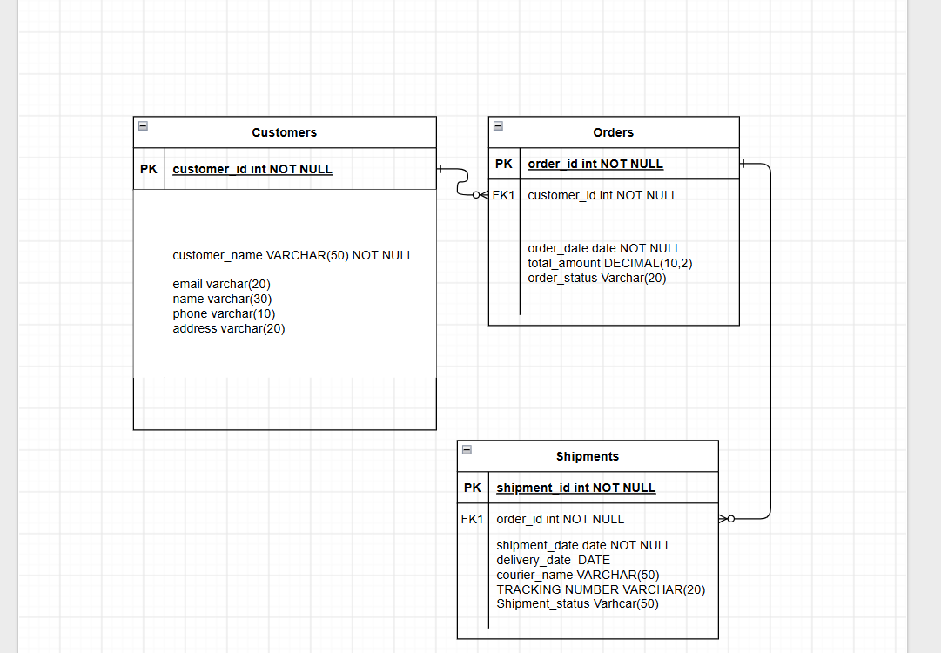
An ER Diagram (Entity-Relationship Diagram) is a visual representation of the entities in a database and the relationships between them. It is commonly used during database design

Task 2: What do you understand by Indexing in DBMS? How does it work?
Definition
Indexing is a technique in DBMS used to improve the speed of data retrieval operations. It creates a separate data structure (called an index) that stores the values of one or more columns along with pointers to the corresponding rows in the table.
Without an index, the database has to scan every row (full table scan) to find the required data.
Task 3: Do you think Indexing strategy improves query performance? Explain.
Answer
Yes. An effective indexing strategy significantly improves query performance by reducing the number of rows the DBMS must scan.
Indexes allow the database to locate records quickly instead of performing a full table scan.

Task-04
What are the ACID properties in RDBMS? Explain.
Property | Meaning | Example
Atomicity | All or nothing | Bank transfer either completes fully or rolls back.
Consistency | Database remains valid | Total balance remains unchanged after transfer.
Isolation | Concurrent transactions do not interfere | Two users withdrawing simultaneously are handled correctly.
Durability | Committed data is permanent | Online order remains saved after a system crash.

Task 6:
Add a check constraint to your column (eg: balance > 0)

CREATE TABLE Employee1 (
emp_id INT PRIMARY KEY,
emp_name VARCHAR(50),
salary INT CHECK (salary > 0)
);

INSERT INTO Employee1
VALUES
(101, 'Rahul', 50000),
(102, 'Priya', 60000);

INSERT INTO Employee1
VALUES
(103, 'Amit', -1000);

ERROR: new row for relation "employee1" violates check constraint "employee1_salary_check"
Failing row contains (103, Amit, -1000).

SQL state: 23514
Detail: Failing row contains (103, Amit, -1000).

Employee Table
CREATE TABLE Employee (
emp_id INT PRIMARY KEY,
emp_name VARCHAR(50),
salary DECIMAL(10,2),
dept_id INT
);

INSERT INTO Employee VALUES
(101,'Alice',50000,1),
(102,'Bob',60000,2),
(103,'Charlie',55000,1),
(104,'David',45000,3),
(105,'Eva',70000,NULL);
Department Table
CREATE TABLE Department (
dept_id INT PRIMARY KEY,
dept_name VARCHAR(50)
);

INSERT INTO Department VALUES
(1,'HR'),
(2,'IT'),
(3,'Finance'),
(4,'Marketing');

Task 7: Use WHERE Clause and check if it works
The WHERE clause is used to filter rows based on a condition.
Example 1: Employees with salary greater than 50,000
SELECT *
FROM Employee
WHERE salary > 50000;
Output
emp_id | emp_name | salary | dept_id
102 | Bob | 60000 | 2
103 | Charlie | 55000 | 1
105 | Eva | 70000 | NULL

Example 2: Employees in Department 1
SELECT *
FROM Employee
WHERE dept_id = 1;

Task 8: Use ORDER BY
The ORDER BY clause sorts the result.
Ascending Order (Default)
SELECT *
FROM Employee
ORDER BY salary;
Descending Order
SELECT *
FROM Employee
ORDER BY salary DESC;
Order by Employee Name
SELECT *
FROM Employee
ORDER BY emp_name ASC;

Task 9: Use LIMIT
The LIMIT clause restricts the number of rows returned.
Display first 3 employees
SELECT *
FROM Employee
LIMIT 3;
Highest-paid employee
SELECT *
FROM Employee
ORDER BY salary DESC
LIMIT 1;
Top 2 highest-paid employees
SELECT *
FROM Employee
ORDER BY salary DESC
LIMIT 2;

Task 10: Create Queries for Joins
1. INNER JOIN
Returns only matching records from both tables.
SELECT e.emp_id,
e.emp_name,
d.dept_name
FROM Employee e
INNER JOIN Department d
ON e.dept_id = d.dept_id;
Output
emp_id | emp_name | dept_name
101 | Alice | HR
102 | Bob | IT
103 | Charlie | HR
104 | David | Finance

2. LEFT OUTER JOIN
Returns all records from the left table and matching records from the right table.
SELECT e.emp_id,
e.emp_name,
d.dept_name
FROM Employee e
LEFT OUTER JOIN Department d
ON e.dept_id = d.dept_id;
Output
emp_id | emp_name | dept_name
101 | Alice | HR
102 | Bob | IT
103 | Charlie | HR
104 | David | Finance
105 | Eva | NULL

3. RIGHT OUTER JOIN
Returns all records from the right table and matching records from the left table.
SELECT e.emp_id,
e.emp_name,
d.dept_name
FROM Employee e
RIGHT OUTER JOIN Department d
ON e.dept_id = d.dept_id;
Output
emp_id | emp_name | dept_name
101 | Alice | HR
103 | Charlie | HR
102 | Bob | IT
104 | David | Finance
NULL | NULL | Marketing

4. CROSS JOIN
Returns the Cartesian product of both tables (every employee is paired with every department).
SELECT e.emp_name,
d.dept_name
FROM Employee e
CROSS JOIN Department d;
Result: If there are 5 employees and 4 departments, the query returns:
5 × 4 = 20 rows

